starting conditions in the wind tunnel 99: nikkon starts at –25°, during the first subrun the sonics are turned to the left (thus the wind field virtuelly turns from 0 to 360) during the second subrun
(-20°) the sonics are turned to the right
dat and .red files; data are adjusted to r2‘s. This means that the sonics always turn to the right, (which in case of the upside down mounted r2‘s means that the wind turns clockwise). Thus the even runs [0,2,4...] are always reversed. Furthermore the order of the subruns with differing azimuth angle is exchanged for sonics which where mounted upside down (Thus those runs start with nikkon25°).

Sonic type | starting position tunnel  wind direction tunnel: | coordinate system (directed such that the sonic on the left would measure a positive u value) | starting values in the wind tunnel | starting .dat and .red files values | Transformations
CSAT3  u+  v+ | 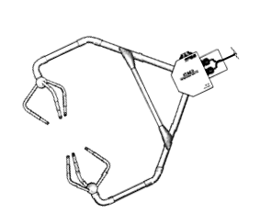 | right handed  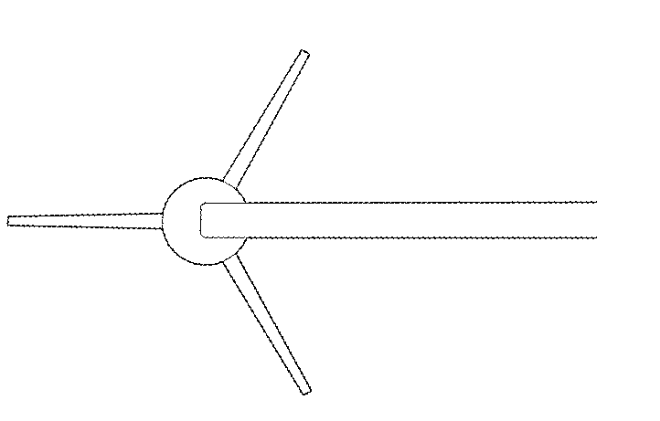 | u[2,0,-2,0,2], [2,0,-2,0,2]  v[0,-2,0,2,0] ,[0,2,0,-2,0]  w neg  first run: nikkon turns left, wind field virtually turns from 360 to 0 | all runs:  even ones are reversed  u(0) is directed into the wind (say northward) u(0)=2  v(0) ) is directed to the ‚east‘ v(0)=0  w(0) is negative  wind field virtually turns from 0 to 360 in the right handed system!!! | right handed to left handed (v= -v)
Gill HS | 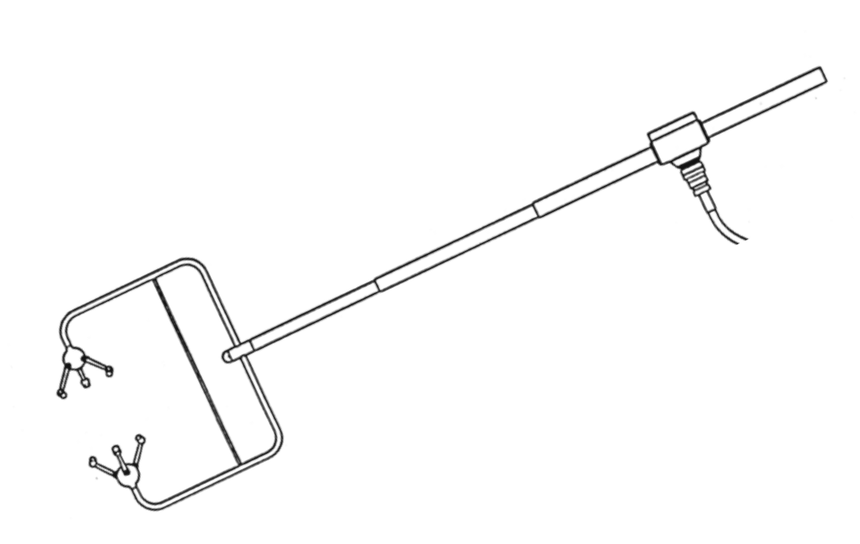 | right handed  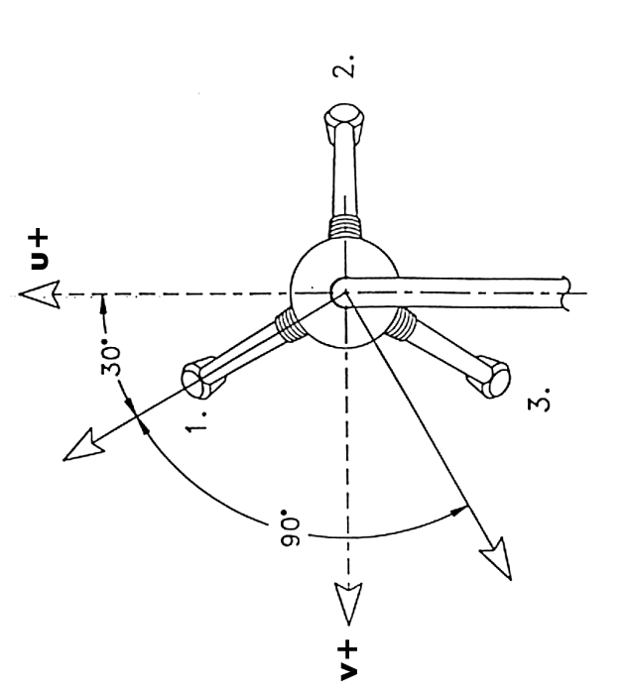 | u[-2,0,2,0,-2], [-2,0,2,0,-2]  v[0,2,0,-2,0],[0,-2,0,2,0]  w neg  even ones are reversed  first run wind field virtually turns from 180 to 0 to 180 in the right handed coordinate system | all runs:  even ones are reversed  u(0) is opposite to the winddirection  v(0) is directed to the ‚west‘ v(0)=0  w(0) is negative  wind field virtually turns from 180 to 360 to 180 in the right handed coordinate system | right handed to left handed (v= -v)
Gill R3 | 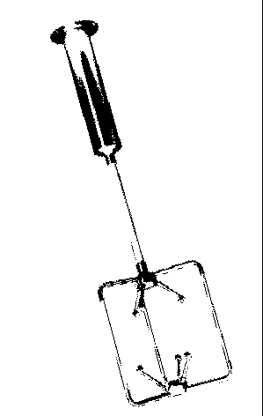 | right handed  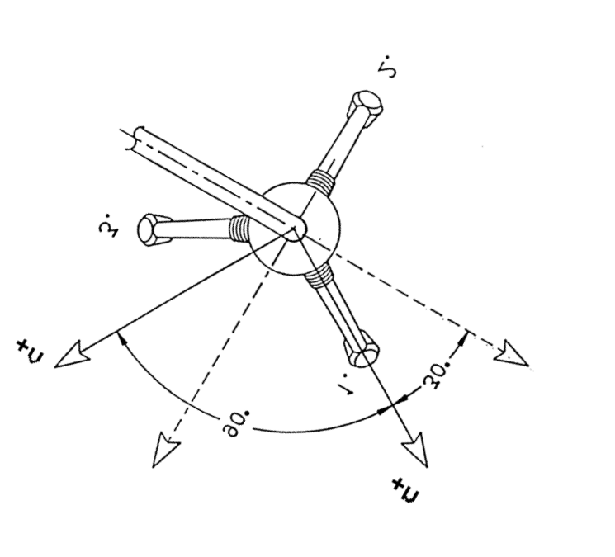 | u[1,2,1,0,-1,-2,-1,0,1]  v[-1.5,2,0,-2,-1.5]  w pos  even ones are reversed | all runs:  even ones are reversed  u has a 30 deg offset to sonic north and thus a 60 deg offset towards ‚tunnel north‘. path 3 is pointing in the wind.  wind field virtually turns from 300 to 0/360 to 300 in the right handed coordinate system | right handed to left handed (v= -v)
Sonic type | starting position tunnel  wind direction tunnel: | coordinate system (directed such that the sonic on the left would measure a positive u value) | starting values in the wind tunnel | starting .dat and .red files values | Transformations
Gill R2 |  | left handed  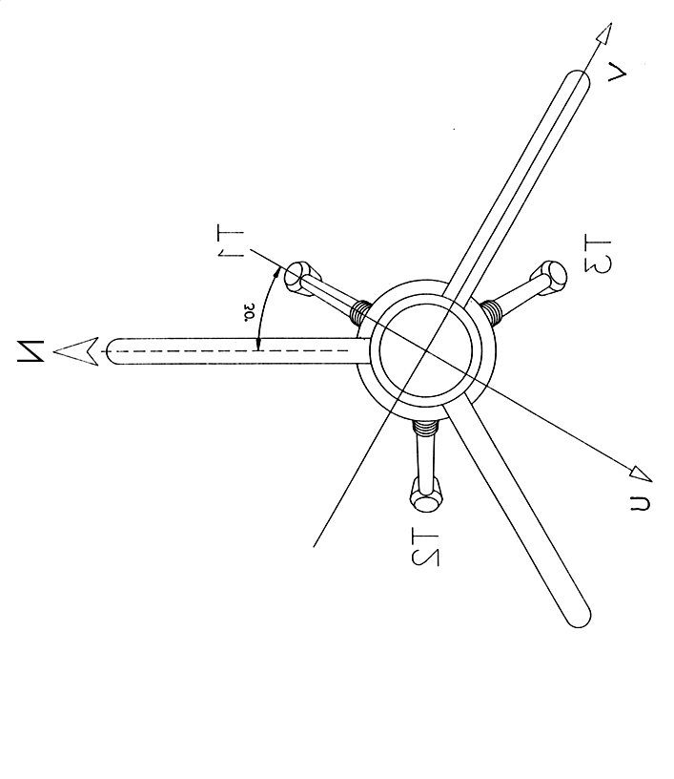 | u[2,0,-2,0,2],[2,0,-2,0,2]*cos(30)  v[0,-2,0,2,0] ,[0,2,0,-2,0]*sin(30)  w pos  even ones are reversed | u(0) is directed to 330° u(0)=1.7  v(0) is directed to 240°v(0)=1  w(0) is negative | rotate 30 °
Metek  9903006 | 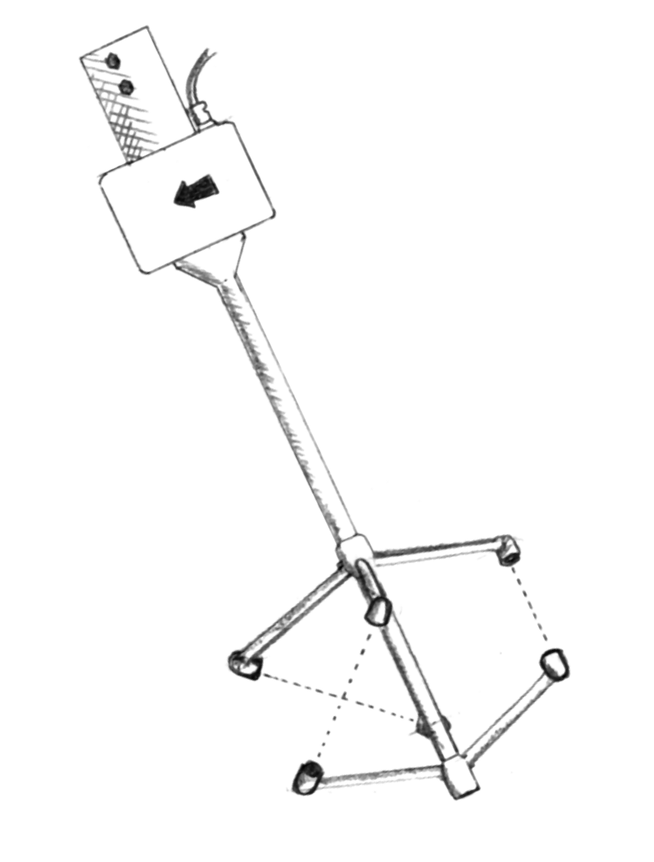 | left handed  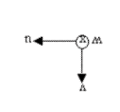 | M9903006  u[-2,0,2,0,-2], [-2,0,2,0,-2]  v[0,2,0,-2,0],[0,-2,0,2,0]  w pos  even ones are reversed  runs are cut as they start at 180 deg and turn cw | u(0) is directed into the wind (say northward) u(0)=2  v(0) is directed to the ‚west‘ v(0)=0  w(0) is negative | -

